Identifying Teacher Incentive Allotment Designated Teachers
  - Educator Certification Online System (ECOS) Certification Report

- Determine who in your district has TEAL access, specifically entity access for the ECOS (Educator Certification Online System) application. This will likely be a Human Resources administrator or Certifications Officer. If you are not sure who to contact, you can request a new entity ECOS account through TEAL with Superintendent approval. If you have trouble creating a new account, please submit a Help Desk ticket. If you require expedited access, and do not receive a response to your Help Desk request within 2 business days, please email tia@tea.texas.gov.
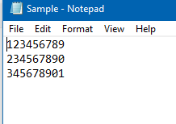
- Create a text or CSV file of SSNs or TEA IDs for any new hires designated teachers or teachers who may have a TIA designation.
*Enter one SSN per line. Do not include hyphens or any additional information.

- Once you have access to the ECOS application, select File Transfer from the left menu.
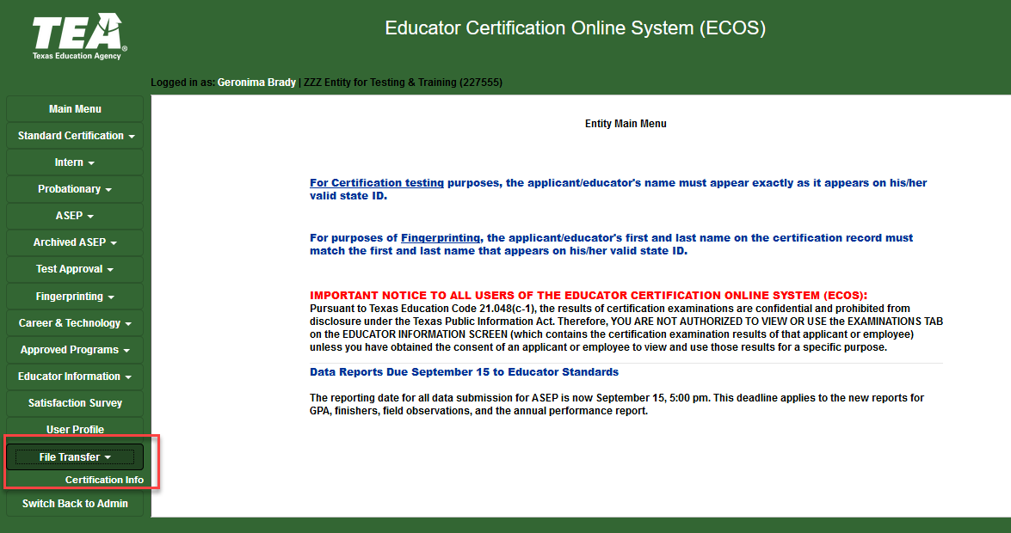

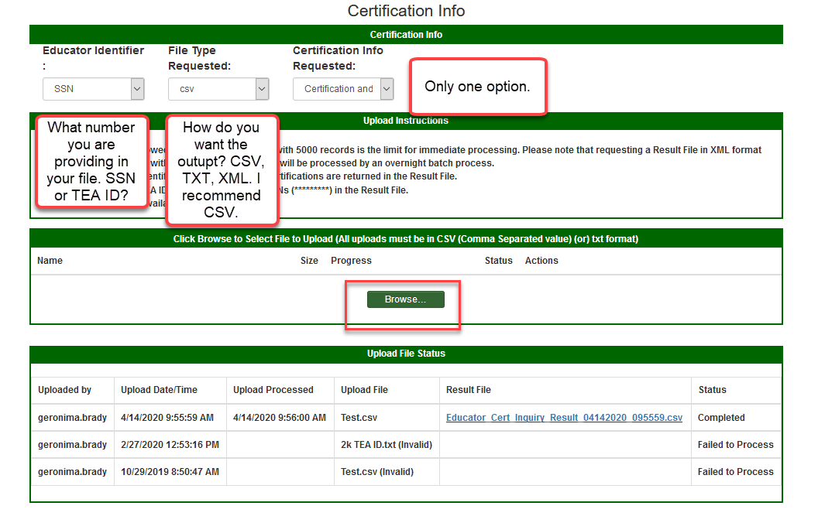
Only one option
Select output. CSV recommended
Select SSN or TEA ID
- Select SSN or TEA ID as the Educator Identifier.
- Select csv as the File Type Requested. Certification Info requested only allows one option.
- Click Browse to upload your text or csv file containing teacher SSNs.
- Once the file is uploaded, you can view and download the results. Results will display for seven days.
- If a teacher has a designation, the level of designation and expiry date will appear in Columns AC and AD

