AAPPL Vendor FAQ
Vendor Name: American Council on the Teaching of Foreign Languages (ACTFL)
Assessment(s) Name: Assessment of Performance toward Proficiency in Languages (AAPPL)
Question | Answer
What Grades are Covered? | 1st-12th Languages Other Than English (LOTE) (Arabic, Mandarin Chinese, English, French, German, Italian, Japanese, Korean, Spanish)
Is there a Pre/Post Test? | Yes, for the Purposes of TIA, districts could use Pre/Post-Test options 2 and 4.
What is the AAPPL? | The AAPPL is a web-based proficiency and performance assessment of K-12 standards-based language learning developed by ACTFL and administered by Language Testing International (LTI). The AAPPL assesses tasks across the three modes of communication as defined by the World-Readiness Standards (Communication) for Learning Languages:  ● Interpretive Reading (IR) and Interpretive Listening (IL),  ● Presentational Writing (PW), and  ● Interpersonal Listening & Speaking (ILS).  AAPPL tasks are informed by the functions described in the ACTFL Proficiency Guidelines and ratings are assigned according to the ACTFL Performance Descriptors for Language Learners. Test items are developed under ACTFL’s direction by language instructors and reviewed by a quality assurance team of experts in each language.  Upon completion and rating of the AAPPL, students and educators receive score reports for each student which identify a proficiency range along with pinpointing a narrower performance score. The Score Reports also include a Score Description and provide strategies for advancing proficiency.
What was the AAPPL designed to do? | AAPPL provides a performance rating that aligns with benchmark points along the continuum towards proficiency. Within the Novice level there are four points (represented as N-1 through N-4), within the Intermediate ranges there are five points (I-1 through I-5), and there is one point within the Advanced range (A-1). The score reports provide an explanation of each score.
How can I use ACTFL’s AAPPL? | The AAPPL specifically measures Interpersonal Speaking and Listening, Interpretive Listening, Presentational Writing, and Interpretive Reading – all the modes in ACTFL’s Performance Descriptors for Language Learners. The AAPPL allows teachers to measure student progress on these descriptors. The AAPPL is best used to set benchmarks for student progress based on their beginning and ending levels within a specific course of study. Because of different starting points and the challenge of gaining proficiency during limited hours of contact, it is important to target a range of proficiency and to understand that the outcomes might be different based on mode (interpersonal speaking, interpretive listening, presentational writing, and interpretive reading) rather than lockstep across modes.  AAPPL was evaluated against and confirmed to align with all assessable TEKS in 2018 for:  - LOTE 114.39 Level I,  - LOTE 114.40 Level II,  - LOTE 114.41 Level III, and  - LOTE 114.42 Level IV.
Does ACTFL’s AAPPL provide expected growth targets for students? | No. However, the AAPPL allows instructors and administrators to identify benchmarks and appropriate growth based on levels attained at the beginning and end of specific learning sequences. Teachers can use the score reports and the specific learning strategies suggested for each mode and rating level, to develop individual goals for students.
How can districts use AAPPL to determine end-of-year student growth for purposes of TIA? | Districts can give the AAPPL as a pre-test to get a baseline for student growth progress. Districts could define expected growth as moving up a specific number of performance bands. For instance, a district could determine that expected growth is defined as moving up two performance bands. In this case, if a student started the year at the N-1 Performance Score and then scored N-3 on the post-test, they would have moved up two bands, thereby showing growth per the district’s definition. It is up to the district to decide what constitutes expected growth.  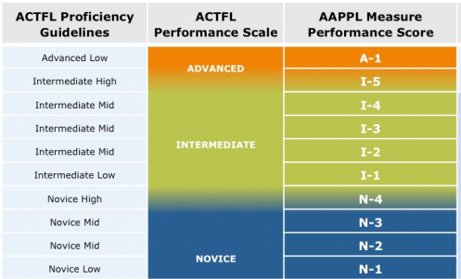  For the purposes of TIA, districts could use option 4 with a district-created pre-test, district set growth targets, and 3rd party post-test or option 2 with 3rd party pre-test with district set growth targets and a 3rd party post-test.
What types of data reporting capabilities are included with the AAPPL? | Filtering options allow higher-level users to see all the data at once, or filtered by school, teacher, language, course level, etc.  AAPPL reports available in the LTI Client Site include the following:  - Longitudinal reports show students’ progress across testing events and would likely be the primary tool used for the TIA program.  - The National Report shows student performance (as a customizable cohort) against students of a similar cohort nationally.  - School Report shows student outcomes within a given school.  Additionally, Client Site users can export a variety of test result details to Excel.

For more information on this resource please refer to the vendor website and reach out to a representative.
Vendor Website: https://www.actfl.org
Vendor Contact: Margaret Malone, mmalone@actfl.org
For more information on the Teacher Incentive Allotment, please visit the Teacher Incentive Allotment website.

